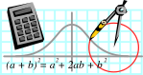  Rossmoyne SHS  Mathematics  Department | MATHEMATICS 2CD | Semester 1 2011  EXAMINATION

NAME:
TEACHER: Belonogoff Fletcher Longley

Pui Tay

Marking Guide
Section One:
Calculator-free

Time allowed for this section
Reading time before commencing work: 5 minutes
Working time for this section: 50 minutes

Material required/recommended for this section

To be provided by the supervisor
This Question/Answer Booklet
Formula Sheet

To be provided by the candidate
Standard items: pens, pencils, pencil sharpener, eraser, correction fluid, ruler, highlighters

Special items: nil

Important note to candidates
No other items may be used in this section of the examination. It is your responsibility to ensure that you do not have any unauthorised notes or other items of a non-personal nature in the examination room. If you have any unauthorised material with you, hand it to the supervisor before reading any further.

Section | Number of questions available | Number of questions to be answered | Suggested working time  (minutes) | Marks  available
Section One:  Calculator-free | 9 | 9 | 50 | 40
Section Two:  Calculator-assumed | 17 | 17 | 100 | 80
 |  |  |  | 120

Instructions to candidates

1. Write your answers in the spaces provided in this Question/Answer Booklet. Spare pages are included at the end of this booklet. They can be used for planning your responses and/or as additional space if required to continue an answer.
  - Planning: If you use the spare pages for planning, indicate this clearly at the top of the page.
  - Continuing an answer: If you need to use the space to continue an answer, indicate in the original answer space where the answer is continued, i.e. give the page number. Fill in the number of the question(s) that you are continuing to answer at the top of the page.

2. Show all your working clearly. Your working should be in sufficient detail to allow your answers to be checked readily and for marks to be awarded for reasoning. Incorrect answers given without supporting reasoning cannot be allocated any marks. For any question or part question worth more than two marks, valid working or justification is required to receive full marks. If you repeat an answer to any question, ensure that you cancel the answer you do not wish to have marked.

3. It is recommended that you do not use pencil except in diagrams.

QUESTION | MARKS AVAILABLE | STUDENT MARK
1 | 5
2 | 5
3 | 4
4 | 5
5 | 5
6 | 4
7 | 4
8 | 5
9 | 3
TOTAL | 40

1. [5 marks]

Set P = {8, 10, 12, 16}. Set Q = {2, 4, 8, 12, 14, 16}. The Universal set is the set of positive even
numbers ≤ 16.

(a) Draw a Venn diagram to show the relationship between the sets. 

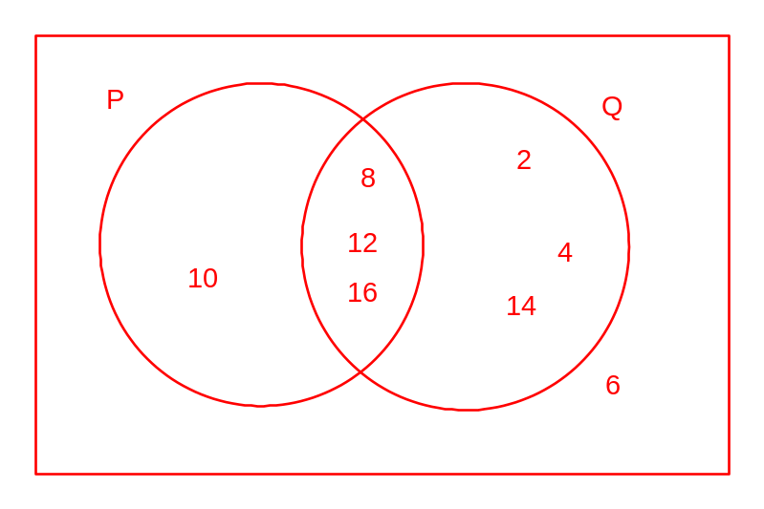

Give the following:
3 
(b) |(P ∩ Q)| ……………….

_ {2, 4, 14} 
(c) P ∩ Q ……………….

_____ {6} 
(d) P ∪ Q ……………….

2. [5 marks]

A number of students are selected at random. 14 of the students had been late this week. 16 of the
students rode to school on bikes. Of those who rode bikes, 7 had been late this week and of those
who had not been late this week, 10 did not ride a bike.

Display the information in a 2-way table and complete the table. for given data  for completion

Bikes

 |  | Yes | No | Total
 | Yes | 7 | 7 | 14
Late | No | 9 | 10 | 19
 | Total | 16 | 17 | 33

Give the following as fractions in simplest form:

(a) What is the probability that a student chosen at random from this group rides a bike but isn't late? 3/11 

…………

7/17 
(b) Given that a student is not a bike rider what is the probability that he is late? …………

19/33 
(c) What is the probability that the student is not late? .................
3. [4 marks]

A spinner is divided into 12 equal segments with each segment labelled A, B or C so that P(A) = 1/4 ,
P(B) = 1/3 and P(C) = 5/12

Show how the segments of the following spinner could be marked to reflect these probabilities
if no 2 adjacent segments should be the labelled the same.  (other configurations possible)

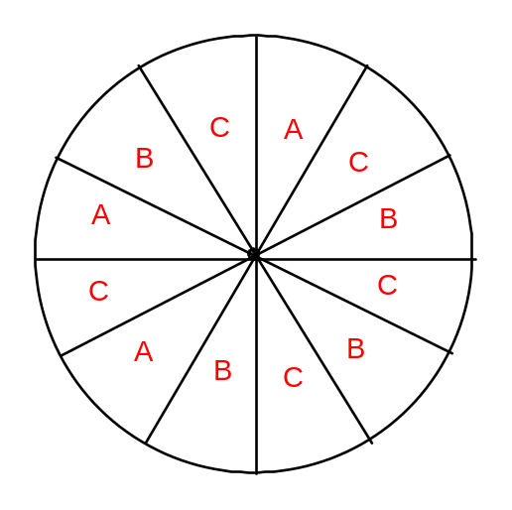 15 
(a) If the spinner is spun 36 times how many times would you expect it to stop on C? ………..

7/12 
(b) What is the probability it doesn't stop on a C? ………..

(c) Players in a raffle may put their money on an A turning up, a B turning up or a C turning up.
If $6 is won when the spinner stops on an A, what prize value should be given if it stops on a C
to make it fair?

3/12 gives 6 dollars so 5/12 should give 3/5 × $6 = 3/60
$3.60 
................

4. [5 marks]

The following is a maximal flow diagram for a network.

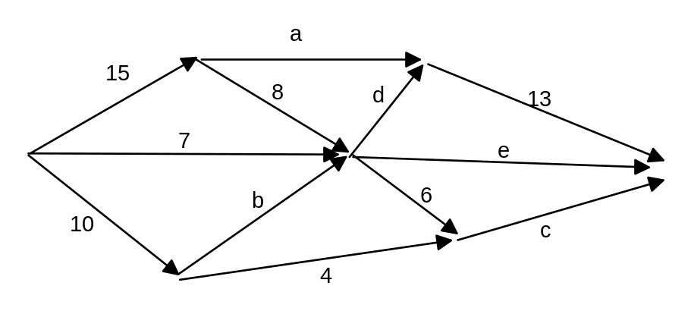
Determine the missing values:

a = 15 − 8 = 7 b = 10 − 4 = 6 c = 6 + 4 = 10

d = 13 − 7 = 6 e = 8 + 7 + 6 − 6 − 6 = 9

7  6  10  6  9 
a …………. b …………. c ………….. d …………. e …………..

5. [5 marks] _
4.83
(a) Give 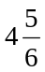 as a recurring decimal. ………………
4.58×10⁻⁵ 
(b) Express 0.0000458 in scientific notation ………………

205.5 
(c) Round 205.462 to 4 significant figures ………………

269 400 
(d) Round 269 423 to the nearest hundred ………………

2040 
(e) Express 2.04×10³ as a decimal ……………..

6. [4 marks]

A line passes through the points (0, 4) and (5, 14).

(a) What is the gradient of the line?

(14 − 4)/(5 − 0) = 2  2
…………

(b) Determine the equation of the line.

y = 2x + 4 
……………………………

(c) What is the equation of the line perpendicular to it that passes through the origin

y = −½ x 
……………………………

7. [4 marks]

A quadratic function is given by y = 2(x − 4)(x + 6)

Give the following:
4, −6 
(a) the roots of the equation ……………………..

x = −1 
(b) the line of symmetry ……………………..

(−1, −50) 
(c) the turning point ……………………..

(0,−48) 
(c) the y-intercept ……………………..

8. [5 marks]

The dot frequency graph below shows the scores of 10 students in a test.
Find the mean, median and mode of the dataset.

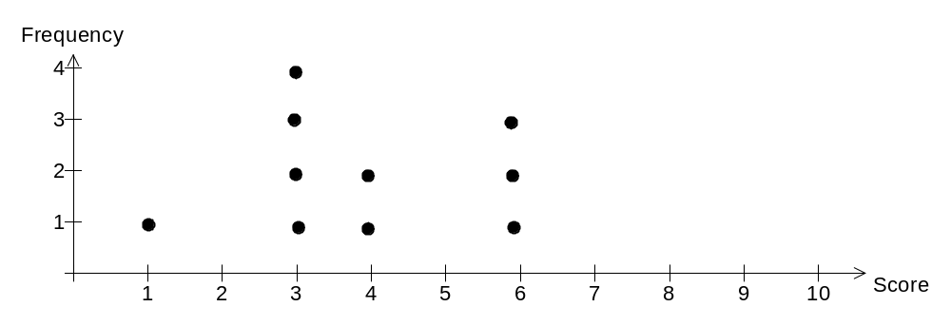

Total = 1 + 4×3 + 2×4 + 3×6 = 39

3.9  3.5  3 
Mean …………………. Median ……………….. Mode ………….

4 
If a score of 7 is added to the dataset what is the median of the new dataset? ………….

9. [3 marks]

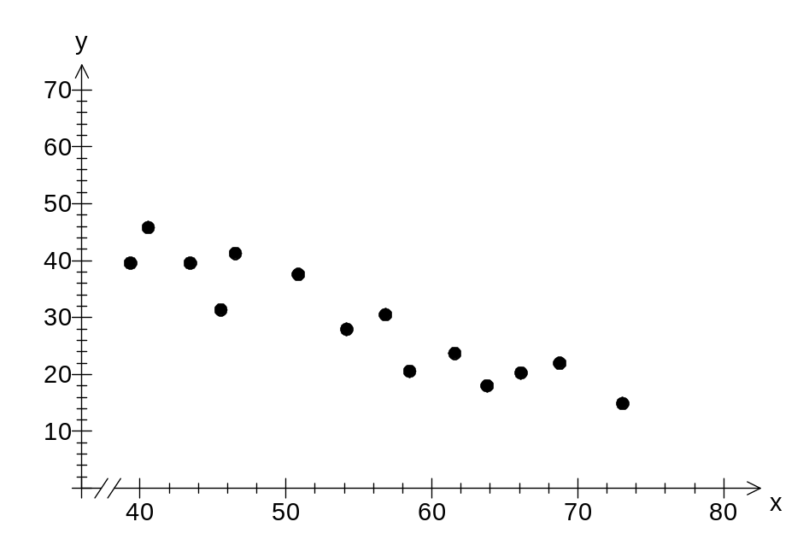

Which of the following equations is most likely to be the line of best fit of the scattergraph
above?

y = 0.89 x + 48

y = −0.93x + 82 

y = −0.93x + 49

y = 0.93x + 20

If the x-axis represents age and the y-axis represents the score on a mathematics speed test,
how would you interpret the y-intercept?

the score for a new born child 

Does this seem reasonable?
No, a new born baby cannot do mathematics 
............................................................................................................................................

END SECTION ONE

